# Composite Formatting

Podemos usar composite formatting en los siguientes metodos

* Console.Writeline
* String.Format
* StringBuilder.AppendFormat
* TextWriter.WriteLine
* Debug.WriteLine
* Trace (varios métodos)

Cada item del formato esta conformado como sigue:

**{**index[,alignment][:formatString]**}**

Los unicos elementos obligatorios son las llaves y el index, el resto es opcional

## Formatos Numericos Standard

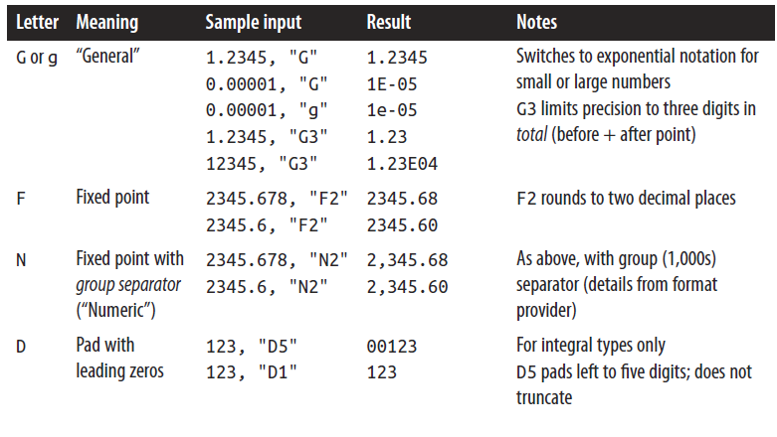

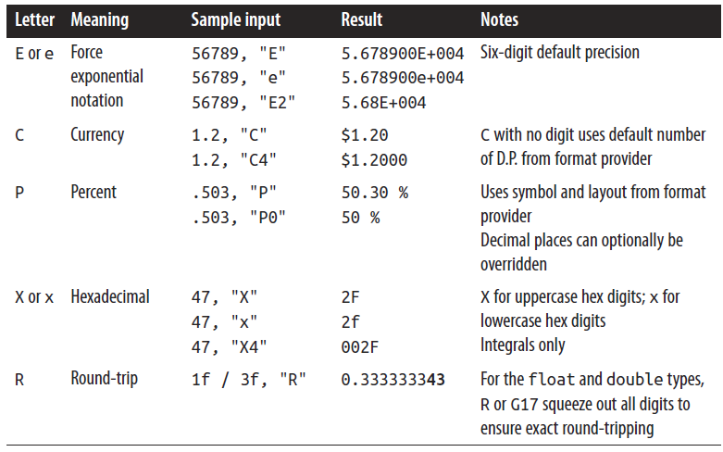

## Formatos Numericos Custom

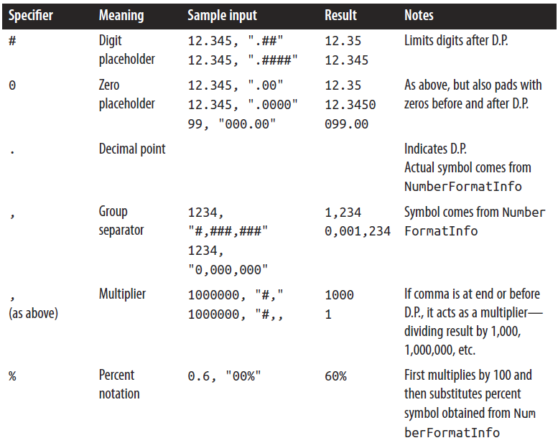

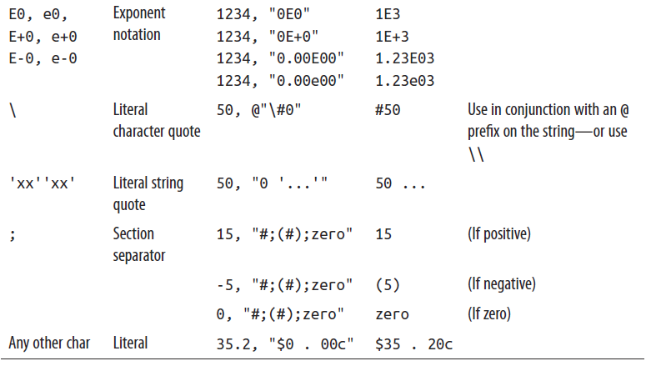

## Formatos de Fecha y Hora Standard (dependientes de la cultura)

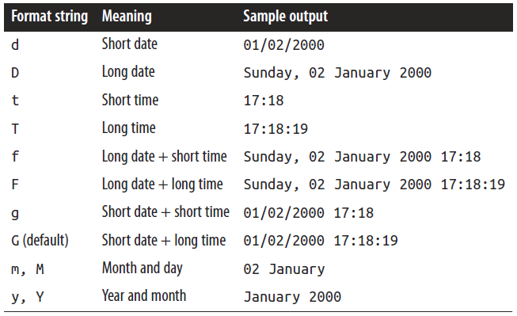

## Formatos de Fecha y Hora Standard (independientes de la cultura)

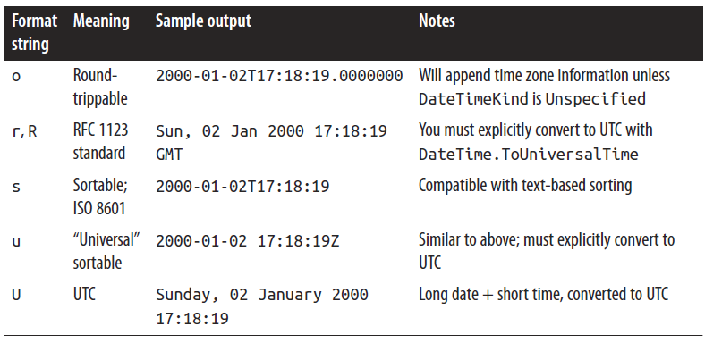

## Formatos de Fecha y Hora Custom

| Format specifier | Description | Examples |
| --- | --- | --- |
| "d" | The day of the month, from 1 through 31. | 2009-06-01T13:45:30 -> 1  2009-06-15T13:45:30 -> 15 |
| "dd" | The day of the month, from 01 through 31. | 2009-06-01T13:45:30 -> 01  2009-06-15T13:45:30 -> 15 |
| "ddd" | The abbreviated name of the day of the week. | 2009-06-15T13:45:30 -> Mon (en-US)  2009-06-15T13:45:30 -> Пн (ru-RU)  2009-06-15T13:45:30 -> lun. (fr-FR) |
| "dddd" | The full name of the day of the week. | 2009-06-15T13:45:30 -> Monday (en-US)  2009-06-15T13:45:30 -> понедельник (ru-RU)  2009-06-15T13:45:30 -> lundi (fr-FR) |
| "f" | The tenths of a second in a date and time value. | 2009-06-15T13:45:30.6170000 -> 6  2009-06-15T13:45:30.05 -> 0 |
| "ff" | The hundredths of a second in a date and time value. | 2009-06-15T13:45:30.6170000 -> 61  2009-06-15T13:45:30.0050000 -> 00 |
| "fff" | The milliseconds in a date and time value. | 6/15/2009 13:45:30.617 -> 617  6/15/2009 13:45:30.0005 -> 000 |
| "ffff" | The ten thousandths of a second in a date and time value. | 2009-06-15T13:45:30.6175000 -> 6175  2009-06-15T13:45:30.0000500 -> 0000 |
| "fffff" | The hundred thousandths of a second in a date and time value. | 2009-06-15T13:45:30.6175400 -> 61754  6/15/2009 13:45:30.000005 -> 00000 |
| "ffffff" | The millionths of a second in a date and time value. | 2009-06-15T13:45:30.6175420 -> 617542  2009-06-15T13:45:30.0000005 -> 000000 |
| "fffffff" | The ten millionths of a second in a date and time value. | 2009-06-15T13:45:30.6175425 -> 6175425  2009-06-15T13:45:30.0001150 -> 0001150 |
| "F" | If non-zero, the tenths of a second in a date and time value. | 2009-06-15T13:45:30.6170000 -> 6  2009-06-15T13:45:30.0500000 -> (no output) |
| "FF" | If non-zero, the hundredths of a second in a date and time value. | 2009-06-15T13:45:30.6170000 -> 61  2009-06-15T13:45:30.0050000 -> (no output) |
| "FFF" | If non-zero, the milliseconds in a date and time value. | 2009-06-15T13:45:30.6170000 -> 617  2009-06-15T13:45:30.0005000 -> (no output) |
| "FFFF" | If non-zero, the ten thousandths of a second in a date and time value. | 2009-06-15T13:45:30.5275000 -> 5275  2009-06-15T13:45:30.0000500 -> (no output) |
| "FFFFF" | If non-zero, the hundred thousandths of a second in a date and time value. | 2009-06-15T13:45:30.6175400 -> 61754  2009-06-15T13:45:30.0000050 -> (no output) |
| "FFFFFF" | If non-zero, the millionths of a second in a date and time value. | 2009-06-15T13:45:30.6175420 -> 617542  2009-06-15T13:45:30.0000005 -> (no output) |
| "FFFFFFF" | If non-zero, the ten millionths of a second in a date and time value. | 2009-06-15T13:45:30.6175425 -> 6175425  2009-06-15T13:45:30.0001150 -> 000115 |
| "g", "gg" | The period or era. | 2009-06-15T13:45:30.6170000 -> A.D. |
| "h" | The hour, using a 12-hour clock from 1 to 12. | 2009-06-15T01:45:30 -> 1  2009-06-15T13:45:30 -> 1 |
| "hh" | The hour, using a 12-hour clock from 01 to 12. | 2009-06-15T01:45:30 -> 01  2009-06-15T13:45:30 -> 01 |
| "H" | The hour, using a 24-hour clock from 0 to 23. | 2009-06-15T01:45:30 -> 1  2009-06-15T13:45:30 -> 13 |
| "HH" | The hour, using a 24-hour clock from 00 to 23. | 2009-06-15T01:45:30 -> 01  2009-06-15T13:45:30 -> 13 |
| "K" | Time zone information. | With [DateTime](https://msdn.microsoft.com/en-us/library/system.datetime%28v=vs.110%29.aspx) values:  2009-06-15T13:45:30, Kind Unspecified ->  2009-06-15T13:45:30, Kind Utc -> Z  2009-06-15T13:45:30, Kind Local -> -07:00 (depends on local computer settings)  With [DateTimeOffset](https://msdn.microsoft.com/en-us/library/system.datetimeoffset%28v=vs.110%29.aspx) values:  2009-06-15T01:45:30-07:00 --> -07:00  2009-06-15T08:45:30+00:00 --> +00:00 |
| "m" | The minute, from 0 through 59. | 2009-06-15T01:09:30 -> 9  2009-06-15T13:29:30 -> 29 |
| "mm" | The minute, from 00 through 59. | 2009-06-15T01:09:30 -> 09  2009-06-15T01:45:30 -> 45 |
| "M" | The month, from 1 through 12. | 2009-06-15T13:45:30 -> 6 |
| "MM" | The month, from 01 through 12. | 2009-06-15T13:45:30 -> 06 |
| "MMM" | The abbreviated name of the month. | 2009-06-15T13:45:30 -> Jun (en-US)  2009-06-15T13:45:30 -> juin (fr-FR)  2009-06-15T13:45:30 -> Jun (zu-ZA) |
| "MMMM" | The full name of the month. | 2009-06-15T13:45:30 -> June (en-US)  2009-06-15T13:45:30 -> juni (da-DK)  2009-06-15T13:45:30 -> uJuni (zu-ZA) |
| "s" | The second, from 0 through 59. | 2009-06-15T13:45:09 -> 9 |
| "ss" | The second, from 00 through 59. | 2009-06-15T13:45:09 -> 09 |
| "t" | The first character of the AM/PM designator. | 2009-06-15T13:45:30 -> P (en-US)  2009-06-15T13:45:30 -> 午 (ja-JP)  2009-06-15T13:45:30 -> (fr-FR) |
| "tt" | The AM/PM designator. | 2009-06-15T13:45:30 -> PM (en-US)  2009-06-15T13:45:30 -> 午後 (ja-JP)  2009-06-15T13:45:30 -> (fr-FR) |
| "y" | The year, from 0 to 99. | 0001-01-01T00:00:00 -> 1  0900-01-01T00:00:00 -> 0  1900-01-01T00:00:00 -> 0  2009-06-15T13:45:30 -> 9  2019-06-15T13:45:30 -> 19 |
| "yy" | The year, from 00 to 99. | 0001-01-01T00:00:00 -> 01  0900-01-01T00:00:00 -> 00  1900-01-01T00:00:00 -> 00  2019-06-15T13:45:30 -> 19 |
| "yyy" | The year, with a minimum of three digits. | 0001-01-01T00:00:00 -> 001  0900-01-01T00:00:00 -> 900  1900-01-01T00:00:00 -> 1900  2009-06-15T13:45:30 -> 2009 |
| "yyyy" | The year as a four-digit number. | 0001-01-01T00:00:00 -> 0001  0900-01-01T00:00:00 -> 0900  1900-01-01T00:00:00 -> 1900  2009-06-15T13:45:30 -> 2009 |
| "yyyyy" | The year as a five-digit number. | 0001-01-01T00:00:00 -> 00001  2009-06-15T13:45:30 -> 02009 |
| "z" | Hours offset from UTC, with no leading zeros. | 2009-06-15T13:45:30-07:00 -> -7 |
| "zz" | Hours offset from UTC, with a leading zero for a single-digit value. | 2009-06-15T13:45:30-07:00 -> -07 |
| "zzz" | Hours and minutes offset from UTC. | 2009-06-15T13:45:30-07:00 -> -07:00 |
| ":" | The time separator. | 2009-06-15T13:45:30 -> : (en-US)  2009-06-15T13:45:30 -> . (it-IT)  2009-06-15T13:45:30 -> : (ja-JP) |
| "/" | The date separator. | 2009-06-15T13:45:30 -> / (en-US)  2009-06-15T13:45:30 -> - (ar-DZ)  2009-06-15T13:45:30 -> . (tr-TR) |
| "*string*"  '*string*' | Literal string delimiter. | 2009-06-15T13:45:30 ("arr:" h:m t) -> arr: 1:45 P  2009-06-15T13:45:30 ('arr:' h:m t) -> arr: 1:45 P |
| % | Defines the following character as a custom format specifier. | 2009-06-15T13:45:30 (%h) -> 1 |
| \ | The escape character. | 2009-06-15T13:45:30 (h \h) -> 1 h |
| Any other character | The character is copied to the result string unchanged. | 2009-06-15T01:45:30 (arr hh:mm t) -> arr 01:45 A |